**Word of Life: October 2020**

*Recommended dates are provided, but you are welcome to use these materials at any time!*

**Respect Life Month**

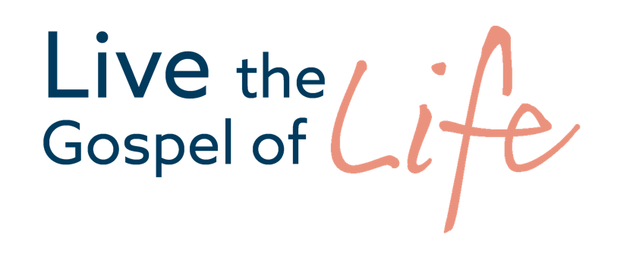

*The 2020–2021 Respect Life Program resources are to assist you in helping Catholics understand, value, and become engaged with building a culture that cherishes every human life.*

*A variety of* [*materials*](https://www.respectlife.org/2020) *are available to order in print or to download online!*

**Featured Resources**

* 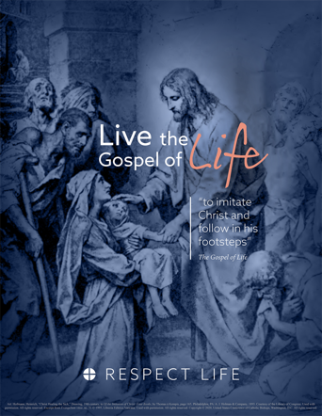[Respect Life Month Action Guide](https://www.usccb.org/resources/respect-life-month-action-guide-2020) *(action ideas, homily helps, a sample timeline & more!)*
* [2020-2021 Respect Life Reflection](https://www.usccb.org/resources/respect-life-program-reflection-2020-2021)
* [Bulletin Cover](https://www.usccb.org/resources/rlp-20-bulletin-cover.png) | [Bulletin Wrapper](https://www.usccb.org/resources/rlp-20-bulletin-wrapper.png)
* [Homily Helps](https://www.usccb.org/resources/respect-life-sunday-2020-homily-notes)

**Sample Pulpit Announcements**

**Option 1: Respect Life Sunday (October 4)**

This weekend, the Church in the United States celebrates Respect Life Sunday, kicking off Respect Life Month. See this week’s bulletin for more information and a short reflection on this year’s theme.

**Option 2: Respect Life Month**

Each October, the Church in the United States celebrates Respect Life Month. See this week’s bulletin for more information and a short reflection on this year’s theme, “Live the Gospel of Life.”

**Sample Bulletin Announcements**

**Option 1: Respect Life Sunday (October 4)**

**Today is Respect Life Sunday!**   
Join Catholics nationwide in celebrating the kickoff of Respect Life Month! **respectlife.org/celebrate**

**Option 2: Respect Life Month**

**October is Respect Life Month!**   
Join Catholics nationwide in celebrating throughout October. Learn how you can participate at **respectlife.org/celebrate**.

**Word of Life – October 2020**

**Intercessions for Life**

|  |  |
| --- | --- |
| **October 4th**  For all Catholics: That on this Respect Life Sunday our resolve may be strengthened  to uphold the dignity  of every human life; *We pray to the Lord:* | **Twenty-seventh Sunday**  **in Ordinary Time**  ***(Observed in the U.S. as***  ***Respect Life Sunday)*** |
| **October 11th**  For women and men suffering after abortion: May the Church’s abortion healing ministry,  Project Rachel, help them find peace and healing through Christ’s endless mercy; *We pray to the Lord:* | **Twenty-eighth Sunday**  **in Ordinary Time** |
| **October 18th**  That the life of every person, from conception to natural death, will be protected in our laws and cherished in our hearts; *We pray to the Lord:* | **Twenty-ninth Sunday**  **in Ordinary Time** |
| **October 25th**  May God grant us the wisdom and courage to lovingly protect His gift of human life at every stage, in sickness and in health; *We pray to the Lord:* | **Thirtieth Sunday**  **in Ordinary Time** |

**Word of Life – October 2020**

**Bulletin Quotes**

|  |  |
| --- | --- |
| **October 4th**  The Gospel of life is intrinsic to the whole Christian life and foundational to the decisions we make on a daily basis. For, “the Gospel of God’s love for man, the Gospel of the dignity of the person and the Gospel of life are a single and indivisible Gospel” (EV 2).  *Excerpt from *Evangelium vitae*, © 1995, Libreria Editrice Vaticana. Used with permission. All rights reserved.  USCCB Secretariat of Pro-Life Activities  2020-2021 Respect Life Reflection, [www.respectlife.org/reflection](http://www.respectlife.org/reflection) | [PDF](https://www.usccb.org/resources/rlp-20-reflection.pdf) | [Word](https://www.usccb.org/resources/rlp-20-reflection.docx) |
| **October 11th**  “I would now like to say a special word to women who have had an abortion. The Church is aware of the many factors which may have influenced your decision, and she does not doubt that in many cases it was a painful and even shattering decision. The wound in your heart may not yet have healed. …But do not give in to discouragement and do not lose hope. …The Father of mercies is ready to give you his forgiveness and his peace in the Sacrament of Reconciliation.”  Pope Saint John Paul II, *Evangelium vitae,* no. 99. © 1995, Libreria Editrice Vaticana.  Used with permission. All rights reserved. | A screenshot of a cell phone  Description automatically generated  [Order](http://store.usccb.org/the-gospel-of-life-p/316-7.htm) | [Read Online](http://w2.vatican.va/content/john-paul-ii/en/encyclicals/documents/hf_jp-ii_enc_25031995_evangelium-vitae.html) |
| **October 18th**  “We are called to reverence and love every human person as ourselves. It is our responsibility to care for and protect human life, especially the lives of the most vulnerable among us. *The Gospel of Life* teaches us that ‘the task of accepting and serving life involves everyone; and this task must be fulfilled above all towards life when it is at its weakest’” (EV 43).  *Excerpt from *Evangelium vitae*, © 1995, Libreria Editrice Vaticana. Used with permission. All rights reserved.  USCCB Secretariat of Pro-Life Activities  “Serving Moms in Need: Living the Gospel of Life”  [respectlife.org/serving-moms-in-need](http://www.respectlife.org/serving-moms-in-need) | [PDF](https://www.usccb.org/resources/rlp-20-bulletin-insert-serving-moms.pdf) | [Word](https://www.usccb.org/resources/rlp-20-bulletin-insert-serving-moms-text-only.docx) |
| **October 25th**  “The Gospel of Life is at the *heart* of Jesus’ saving message to the world. Through the Incarnation and birth of Christ, God reveals to us the dignity of all human life. Human life, as a gift of God, is sacred and inviolable. … Not only must human life not be taken, but it must be protected with loving concern.”  USCCB Secretariat of Pro-Life Activities  “The Gospel of Life: A Brief Summary"  [respectlife.org/gospel-of-life-summary](http://www.respectlife.org/gospel-of-life-summary) | [PDF](https://www.usccb.org/resources/rlp-20-bulletin-insert-ev-summary_0.pdf) | [Word](https://www.usccb.org/resources/rlp-20-bulletin-insert-ev-summary-text-only.docx) |

**Word of Life – October 2020**

**Bulletin Art**

*You are welcome to use these and other downloadable images from the* [***online Respect Life image gallery***](https://www.respectlife.org/respect-life-image-gallery)*, provided they are not altered in any way, other than the size. Thank you!*

**Sunday, October 4th, 2020  
Featuring Reflection: “Live the Gospel of Life”**

* 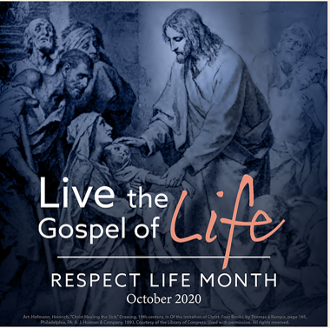Respect Life Reflection: [PDF](https://www.usccb.org/resources/rlp-20-reflection.pdf) | [Word](https://www.usccb.org/resources/rlp-20-reflection.docx)
* Download Image: [English](https://www.usccb.org/resources/rlp-20-rl-month-3-500x500.png) | [Spanish](https://www.usccb.org/resources/rlp-20-rl-month-3-500x500-spn.png)

**Sunday, October 11th, 2020**

**Featuring “Healing within Marriage from an Abortion”**

* 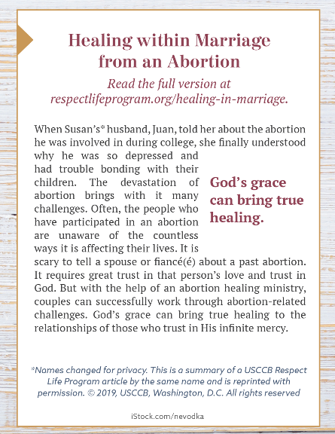Bulletin Box (color): [English](https://static.wixstatic.com/media/c138fd_53d854b7962b4beba6fba89714b6657d~mv2_d_1275_1650_s_2.png/v1/fill/w_1275,h_1650/rlp-19-bulletinboxes-healing-in-marriage.png) | [Spanish](https://static.wixstatic.com/media/c138fd_845993ef8d1544d388fd1376e5f87fc3~mv2_d_1275_1650_s_2.png/v1/fill/w_1275,h_1650/rlp-19-bulletinboxes-healing-in-marriage-spn.png)
* Bulletin Box (grayscale): [English](https://static.wixstatic.com/media/c138fd_090bf52748f74e6fb4be79d8c94d6e10~mv2_d_1275_1650_s_2.png/v1/fill/w_1275,h_1650/rlp-19-bulletinboxes-healing-in-marriage-bw.png) | [Spanish](https://static.wixstatic.com/media/c138fd_50bf550496ef4d958ee863d941747f81~mv2_d_1275_1650_s_2.png/v1/fill/w_1275,h_1650/rlp-19-bulletinboxes-healing-in-marriage-spn-BW.png)
* Bulletin Box (text-only): [English](http://usccb.org/about/pro-life-activities/respect-life-program/2019/upload/rlp-19-bulletin-boxes-eng-compilation-082319-1.docx) | [Spanish](http://www.usccb.org/about/pro-life-activities/respect-life-program/2019/upload/rlp-19-bulletin-boxes-spn-compilation.docx)

**Sunday, October 25th, 2020**

* Download Image: [English](https://www.usccb.org/about/pro-life-activities/word-of-life/upload/EV-84-photo.png) | [Spanish](https://www.usccb.org/about/pro-life-activities/word-of-life/upload/EV-84-photo-spn.png)